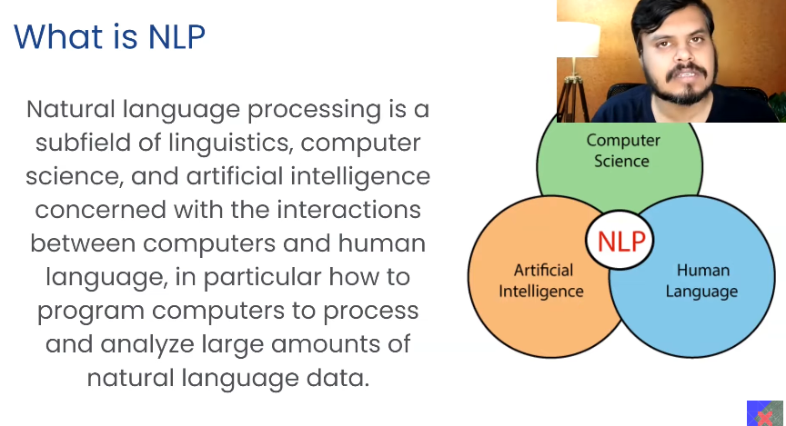
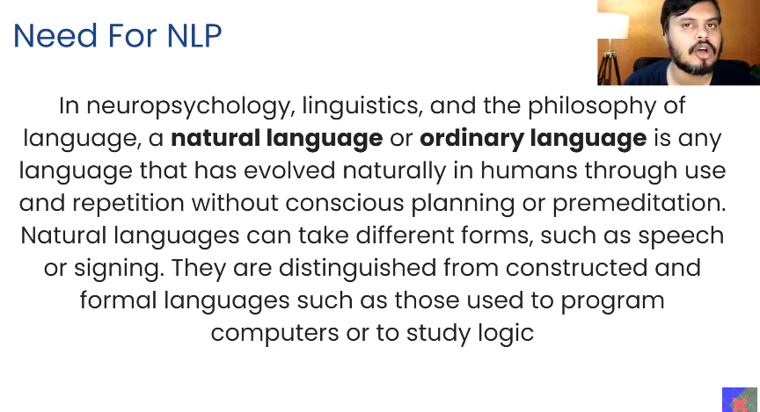
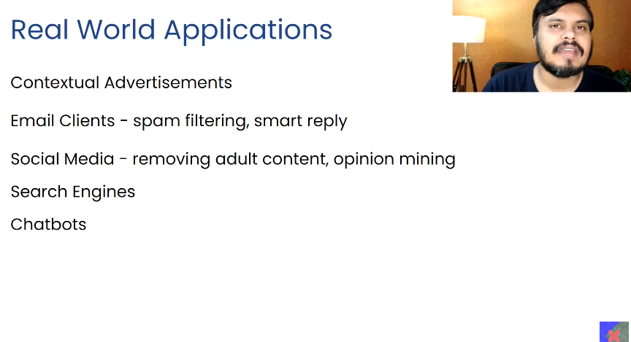
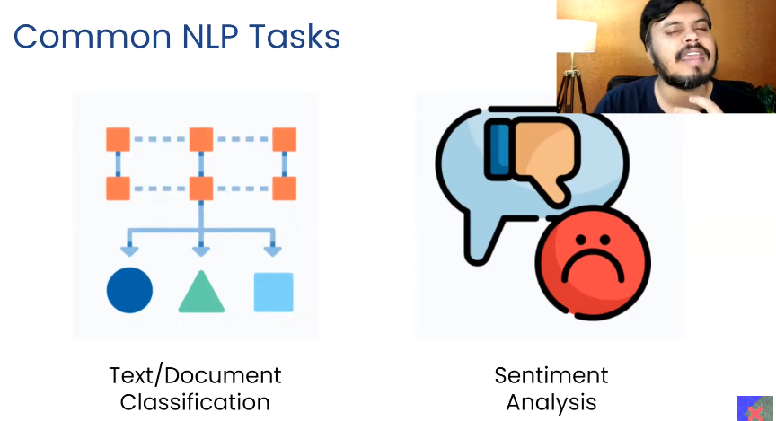
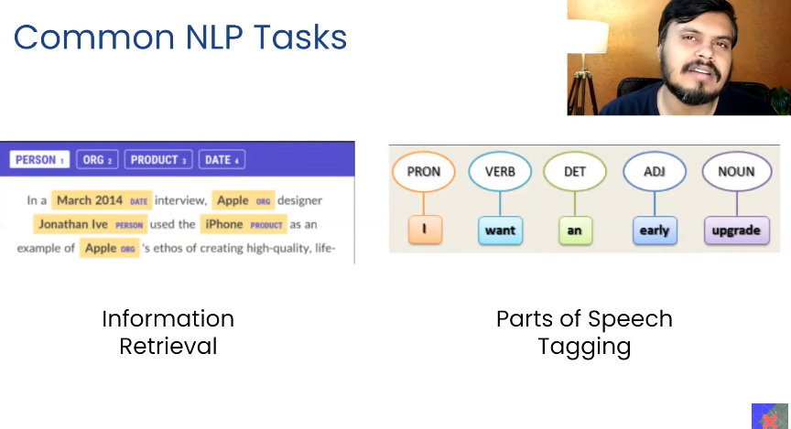
Parts of speech tagging is very much useful in the chatbots.
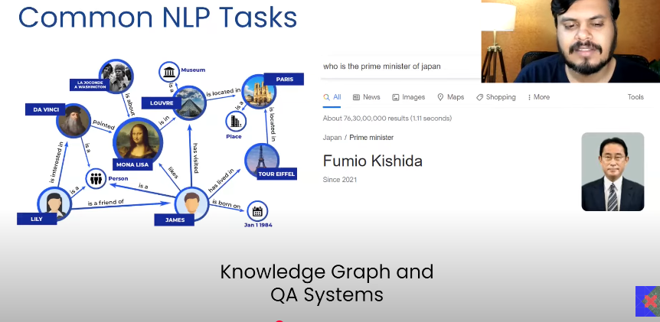
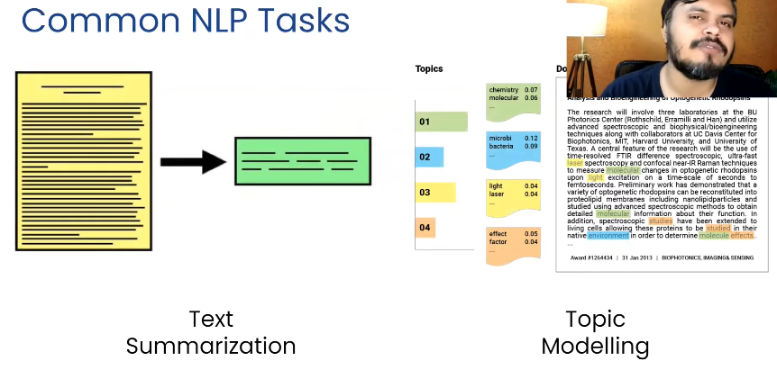

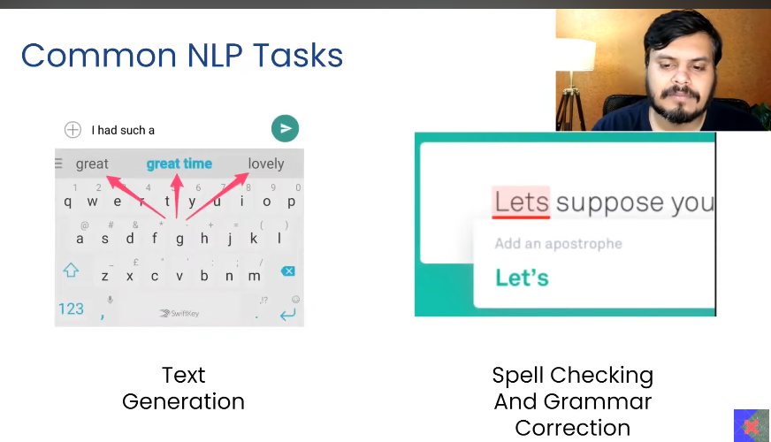
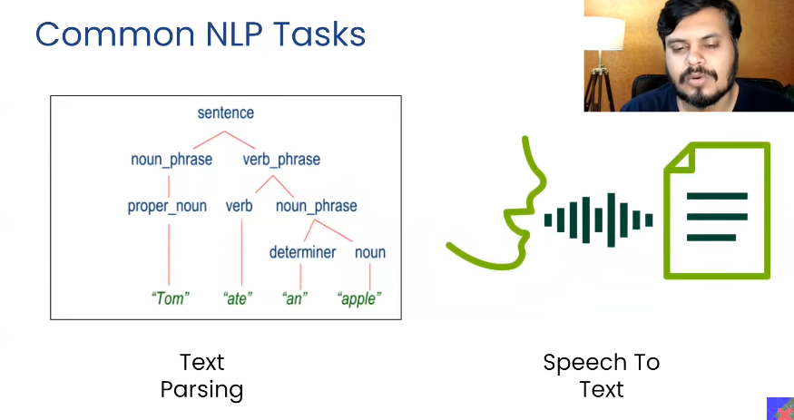

Text parsing is useful in chatbots

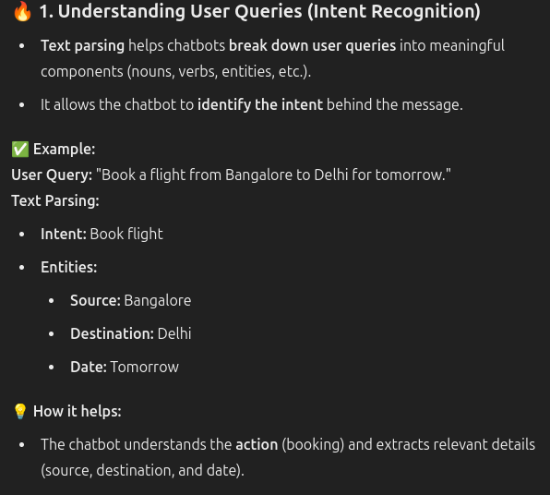
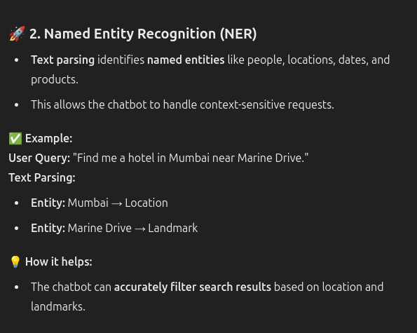
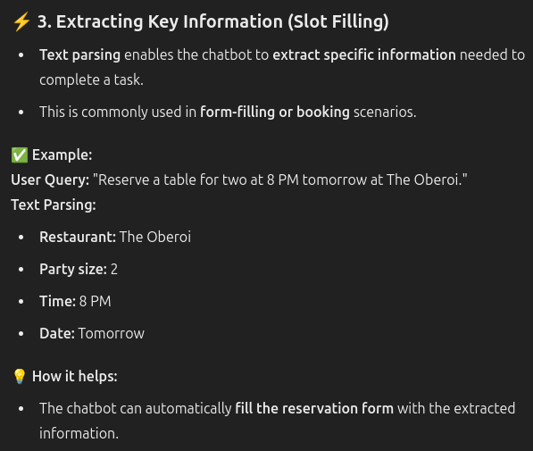
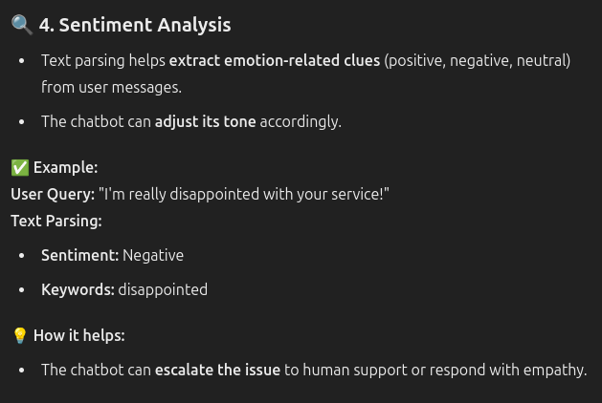

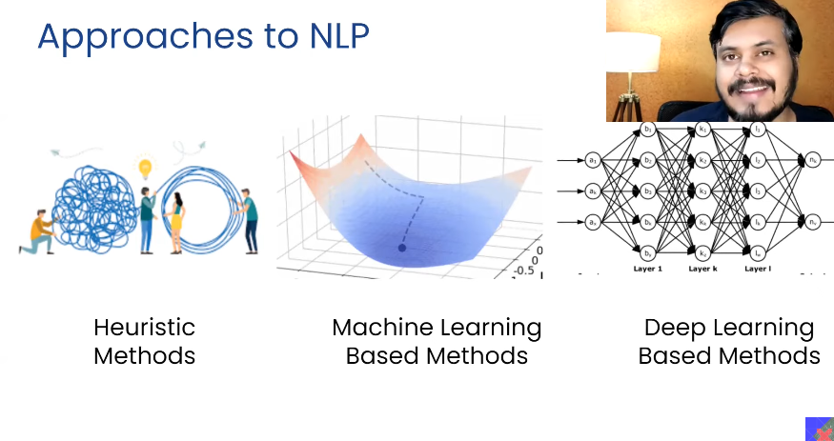

Heuristic:
Trial and error based.
Rules mentioned. Ex: More than 50% positive is considered to be positive, else neg.

Regular expression.
Ex: remove html tags in the whole document.

Wordnet:
- Ex: Jog and run are connected, so while running one apply the shoes.
- These all things are stored and later used.
- Normal dicrionsary is going to give you only the word meaning synonymn and antonyms etc. But this will give you regarding , what are the words are connected to each other and how they are utilized.
- This is used NLTK
Open Mind Common Sense:
1. Englsh common sense are used.
2. These are use later.
Advantage:
Les errors. Used in the current scenarios.
The number rules overruled.

Machine learning approach:
- The rules are framed as according to data, not humanly created rules.
- Workflow:
  - Text vectorization.
  - The machine learning algorithm is going to handle it accordingly.
    - Naive Bayes – textual data.
    - Logistic – Classification problems.
    - SVM - classification purpose.
    - LDA
    - Hidden markov chain – used in POS tagging.
Deep learning:
- Sequence maintain.
- Automatic extraction of feature.
- Architecture:
  - RNN
  - LSTM
  - GRU - used for text generation.
  - CNN -
  - Transformer
  - Autoencders
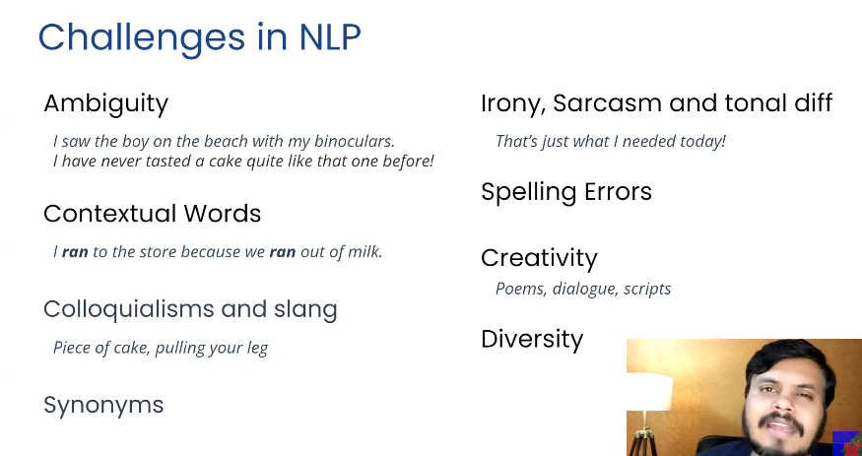

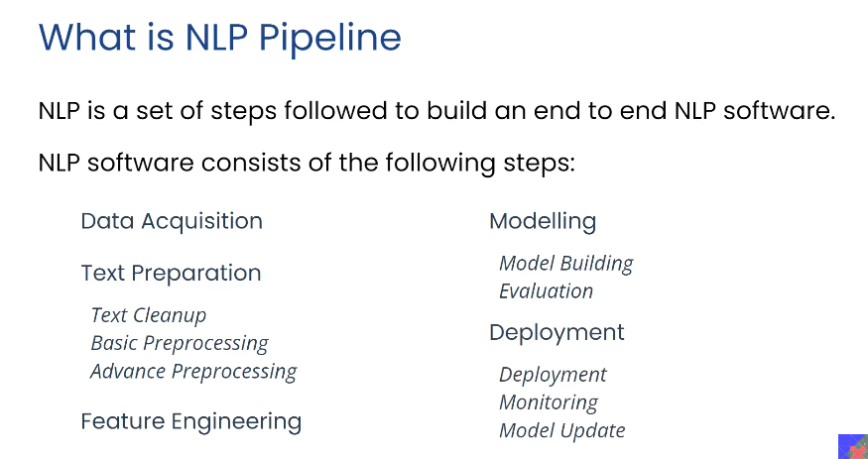
This is useful for classification or sentiment analysis, not for higher hierarchy.
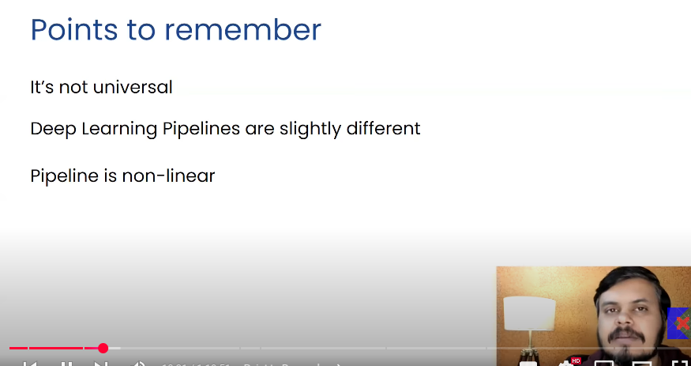

STAGE 1 - DATA COLLECTION
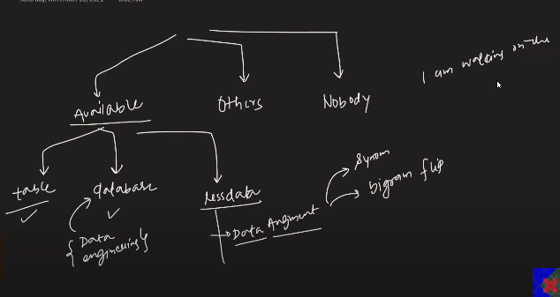
Data Available :
- Table – follow up the pipeline.
- Database :
    - From the running, create the data warehouse.
    - Then use it for further processing.
- Less Data
    - Data Augumentation ;
      - Replace the words in the sentence with the synonyms.
    - Bigram flip
      - Gram - word
      - Ex : “I’m walking on the road” -> I’m walking the on road. Sentiment remains same.
    - Back translate: Convert from one lang to other and then to the same.
    - Additional noise, overall sentence remains same.

Others have data :
- Public dataset - kaggle etc, ight not be according to your application.
- Web scarping - Website of some people, Beautiful Soup.
- API – Rapid API .com- >JSON
- Pdf to text.
- Image - image to text
- Audio – phone call.

No Data available at the start
- Take the customers data through form.

STAGE 2 - Text Processing
- Cleaning
  - HTML tag cleaning
    - 
    - 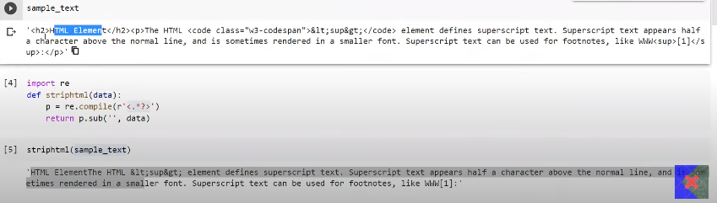
  - Emoji normaisation:
    - 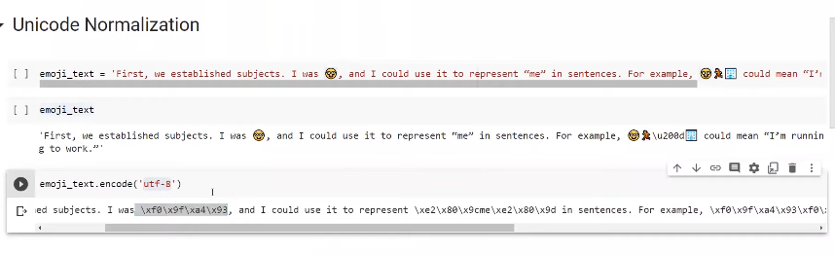
  - Spelling checking
    - 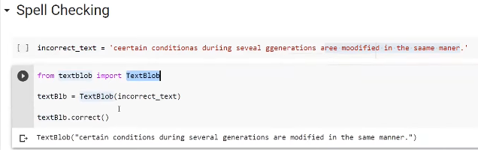
  - The kind of preprocessing depends on the application.

- Basic Programming
  - Basic - Toeknisation
    - Sentence - Based on the full top, convert the paragraph into sentences.
    - Word - Based on the sentence , words are generated.
  - Optional
    - Stop word :
      - Do not have meaning, but contribute in making the sentence.
    - Stemming:
      - Difference in tenses, is removed, get the root word
    - removing punc, digits
    - lower casing
    - Lang detect

- Advanced pre-processing:
  - Parts of speech tagging:
    - I;m living in Banglore, each and word is what? Is it adjective. Noun? Ex: when building the chatbot.
  - Parsing: Sentences syntactic meaning/structure is captured. Chatbot, Q & A .
  - Co-refernce resolution: I’m Sagar, I’m going to be the weapon scientist for Kalki.

If we use the stop words removal:
- Then we cannot make the POS
- No parse tree generation , these all things will happen.

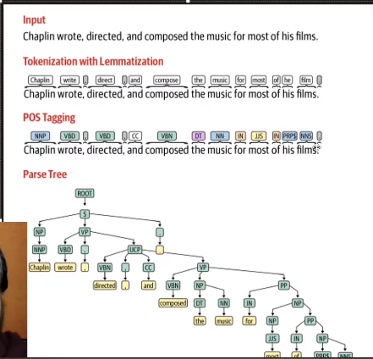
This is text preperation

STEP 3: FEATURE ENGINEERING
Text to numbers. (principle)
To make the sentiment anaslyisis, we are going to make the number of positivea nd negaive words in the total sentence then we will be using that to make sntimanet analysis.
This is basic, which has been given below.
There are many different techniques can be used in order to convert from the text to the numbers, which depends on the application.
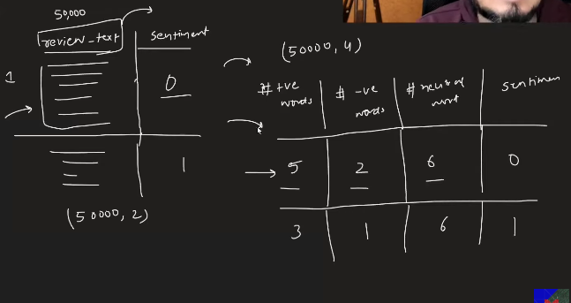
This is also called text vectorisation.
In machine learning, based on this there high chances being the data scientis, we need to make our own features. Then we will apply the algorithm.
In deep learning after the pre-processing, there is no need for making the new features, instead it automatically learns the features.
MACHINE LEARNING Pipeline | DEEP LEARNING Pipeline
Model interpretability is possible, since you are creating the features. Why we are getting this ouput | Features automatically generaed.
Need always domain knowledge. Ex: Hindi translator, need to know the grammar | No model interpratibility, what is going on inside. Ex: because of which words the mail is getting classified as spam and non spam.

Stage 4: Modeling
- Applying algo, and checking the results
- Then test it
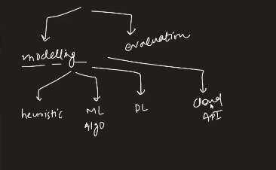
Which technique to be used, depends on :
Amount of data and Nature of problem:
  - If less too,then heuristic methods shall be used. Can’t use DL.
  - If ok as the data increases: Use the ML
  - If too much data: Use DL
  - Combination of the hueristc and ML - use hueristic as new features in ML pipeline.
  - Too much of money: Cloud API
  - Transfer learning, if possible to make the solution.

Model Evaluation:
- Check with the unseen data.
- 2 types:
  - Intrinsic:
    - Use metric, like confusion matrix, FP, FN etc.
    - It is model centric
    - Junior developer
  - Extrinsic:
    - Business centric
    - Senior developer
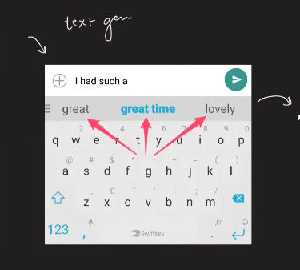
Perplexity: with respect to the real world scenario, when there will be graeter predcitions from the model is called the intrinsic predictions. But how many number of times the text predicted is used tells the extrinsic evaluation.
In 3 output suggestion, one is used then extrinsic evaluation is good. In 1000 words suggestion only one is used then the extrinsic evaluation s no good.
If the intrinsic is great then extrinsic may not be great, but if the extrinsic is great then it means the intrisnsic is by default great.

Stage 5 - Project Deployment:
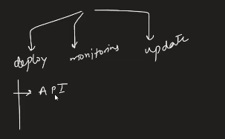‘
Deployment;
- API – spam classification
- Chatbot, whatsapp bot, telegram bot
deploy these and give the output to the end user.
Monitoring:
- Keep checking whether the ML model is working or not.
- Dashboard, what is today, what was yesterday.
- Graphing

Update:
- Based on the new data.
- Based on the new incoming of data, automatically check at the online and deploy it automatically.

